Internal Design Document
of
Electronic Service Delivery System
(ESD)

APP2001

Prepared By



Revision : 0.1
Status : Draft
Document : ESD_IDD_2001

Confidential
Table of Contents

1. Objectives Of Document 3
2. Purpose of the Application 3
2.1. Application ID & Name 3
2.2. Purpose 4
3. Class Diagram of the Application 5
4. Object Interaction Diagrams 8
4.1. Overview 8
4.2. Functionality 9
4.2.1. Submit Request Data Package Operation 9
4.2.1.1. Purpose of the function 9
4.2.1.2. Activated Scenarios 9
4.2.1.3. Input to the function 9
4.2.1.4. Output or Result of the function 9
4.2.1.5. WEB-Page Processing 11
4.2.1.6. Object Interaction Diagram 13
4.2.2. Submit Application Before Payment Operation 14
4.2.2.1. Purpose of the function 14
4.2.2.2. Activated Scenarios 14
4.2.2.3. Input to the function 14
4.2.2.4. Output or Result of the function 14
4.2.2.5. WEB-Page Processing 14
4.2.2.6. Object Interaction Diagram 15
4.2.3. Submit Payment Operation 16
4.2.3.1. Purpose of the function 16
4.2.3.2. Activated Scenarios 16
4.2.3.3. Input to the function 16
4.2.3.4. Output or Result of the function 16
4.2.3.5. WEB-Page Processing 16
4.2.3.6. Object Interaction Diagram 17
5. Application Classes Definition Skeleton 18
6. Constraints to The Application 26
7. Appendices 26

Objectives Of Document
This document will describe the internal design of APP2001 – Application for Renewal of Driving Licence. It also includes details of the JAVA classes involved, plus their functions and interactions.

Purpose of the Application

Application ID & Name
Application ID : APP2001
Application Name : Application for Renewal of Driving Licence
Owner Department : Transport Department (TD)

Purpose
A valid driving licence is required before anyone can drive in Hong Kong. At present, applicants may apply for the renewal of their driving licence immediately over the counters at the 4 licensing offices of the Transport Department or by postal or drop box application.

The purpose of this application is to provide another channel, i.e. electronically through the Electronic Service Delivery (ESD) System, for the public to submit applications for driving licence renewal.

During the process of application APP2001, the applicant can fill in application details, supply supporting documents, change residential and/or postal address and pay licence fee. The system will support input and output in both English and Chinese.

Driving licence renewal applications received from the public via APP2001 will be grouped and passed periodically to the ESD Back End Interface System and then to the Departmental Back End System (VALID) for further processing.
.

Class Diagram of the Application

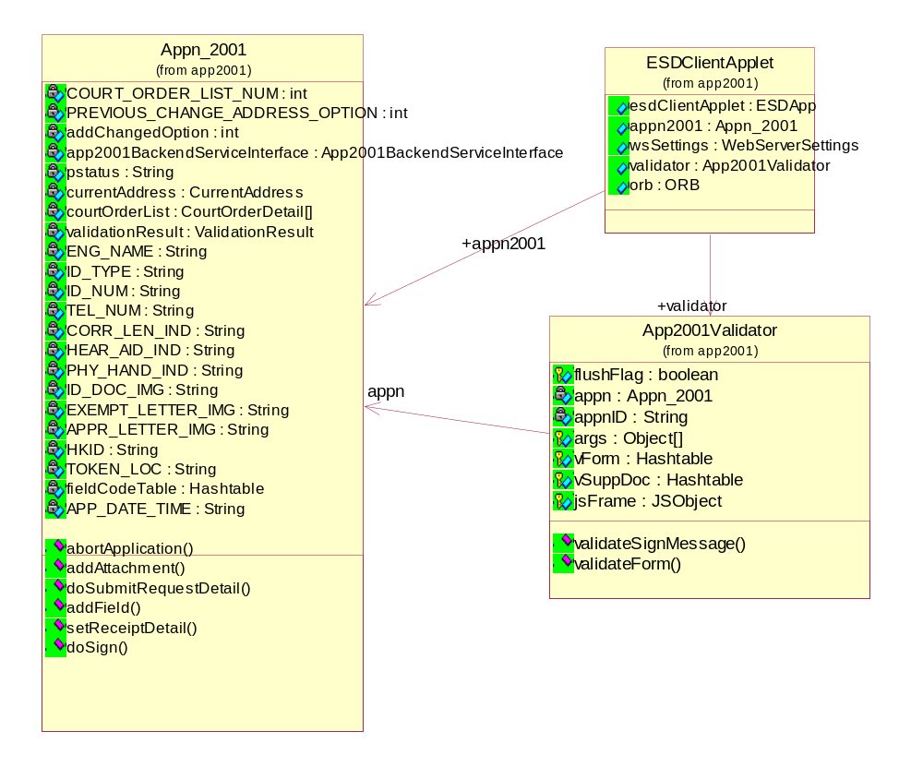
Class Diagram 1: Main (Client)

`
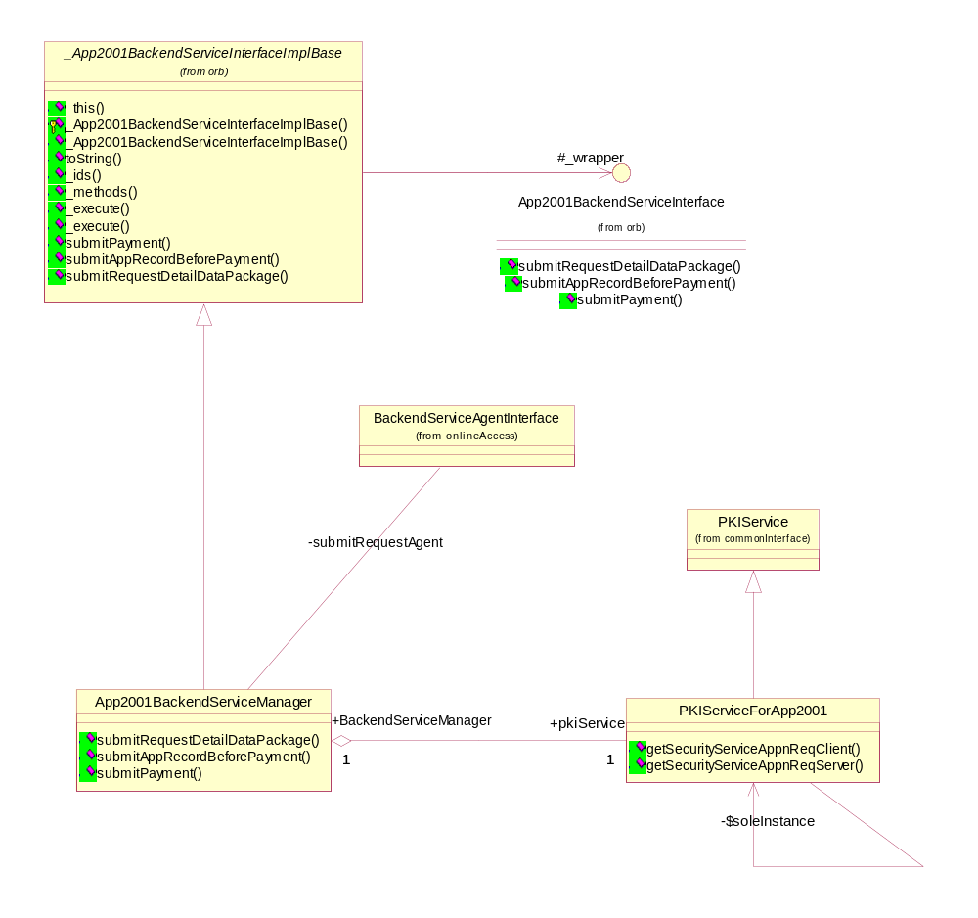
Class Diagram 2: Main (Server)
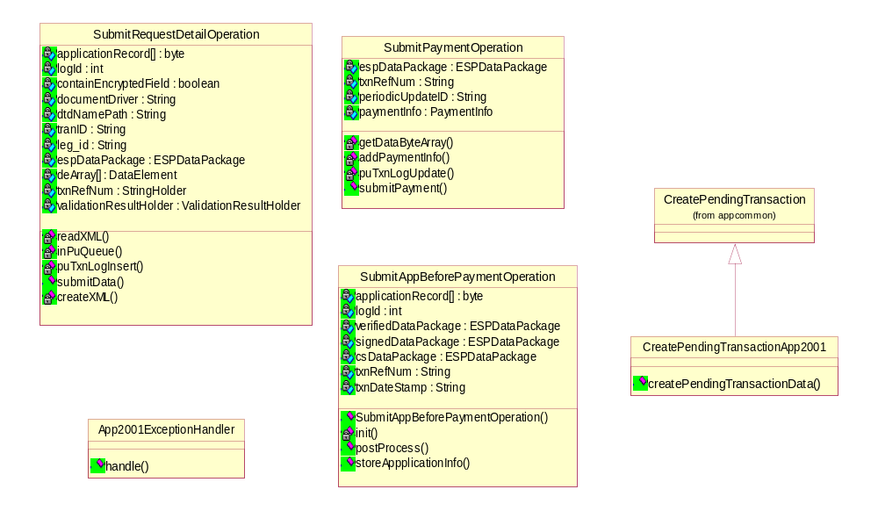
Class Diagram 3: Worker Operations

Object Interaction Diagrams

Overview

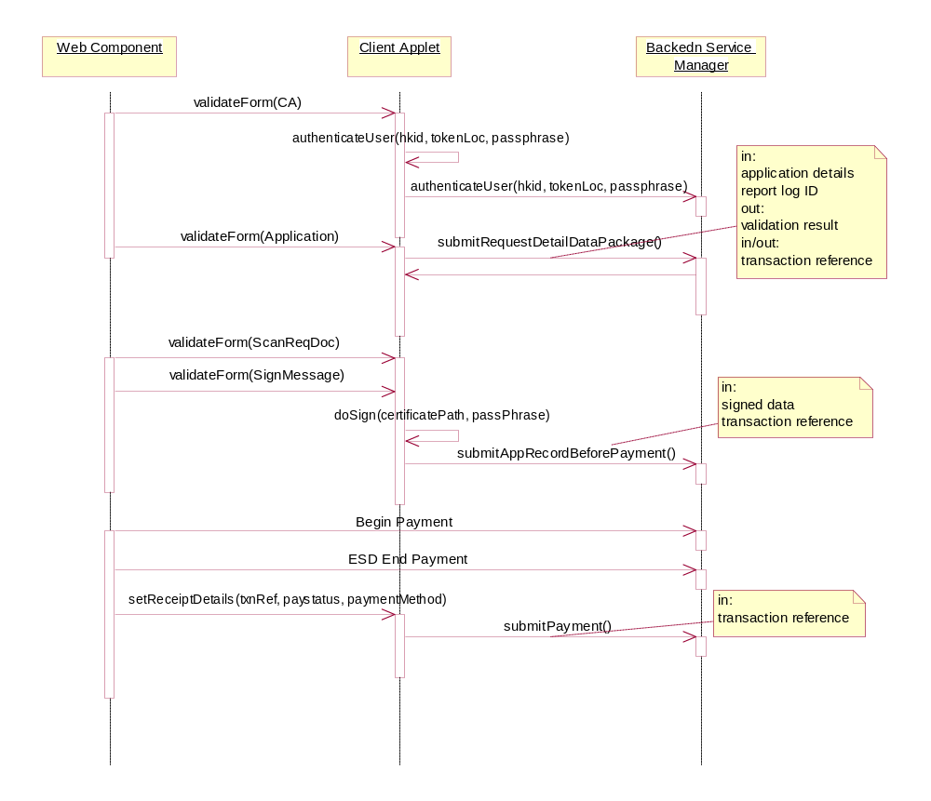
Sequence Diagram 1: Overview

Functionality

Submit Request Data Package Operation

Purpose of the function
- insert initial application details input by user into a datapackage
- serialize and upload datapackage to the content server
- extracted data from datapackage and compiled into an XML request message that will be sent to backend agency servers.
- XML response message/exception received in return will be formatted and returned back to the user
- reject users that have completed a successful transaction with the same legal ID recently

Activated Scenarios
- APP2001-3
- APP2001-4
- APP2001-4-1
- APP2001-4-2

Input to the function
Variable Name | Type | Description
applicationRecord | byte[] | serialized datapackage

Output or Result of the function
- if the request is accepted, a list of validation results including list of fees to be paid, list of supporting documents required, current address registered, etc. will be returned as follow:
Variable Name | Type | Description
txnRefNum | String | transaction reference number
logID | String | logging ID
num_Of_Yr | String | number of years of renewal
lic_Fee_Pay | String | license fee
tava_Pay | String | TAVA fee
billed_Amt | String | billed amount
billing_Time | String | billing time
id_Doc_Ind | boolean | to indicate whether HKID copy is required
exempt_Consu_Ind | boolean | to indicate whether consulate exemption letter is required
appr_Lettr_Ind | boolean | to indicate whether approval letter for disabled drivers is required
brch_Ind | boolean | branch index
resid_Addr1 | String | current registered residential address line 1
resid_Addr2 | String | current registered residential address line 2
resid_Addr3 | String | current registered residential address line 3
resid_Addr4 | String | current registered residential address line 4
resid_Addr5 | String | current registered residential address line 5
post_Addr1 | String | current registered postal address line 1
post_Addr2 | String | current registered postal address line 2
post_Addr3 | String | current registered postal address line 3
post_Addr4 | String | current registered postal address line 4
post_Addr5 | String | current registered postal address line 5
refr_Ord_Ind | boolean | to indicate whether there is any refraining orders
num_Court_Ord | String | number of outstanding court orders
appErrCode | String | application error code
leg_Id | String | legal ID
id_Refmt | String | re-formatted HKID number

- if the request is rejected, either an error message will be displayed, or under certain circumstances, for example: request is rejected due to the driver’s outstanding court orders, a list of court orders will be returned as follow:
Variable Name | Type | Description
refr_Ord_Ind | boolean | to indicate whether there is any refraining orders
num_Court_Ord | String | number of outstanding court orders
warr_Sts | String | warrant status
ref_Court_Case | String | court case reference number
ticket_Num | String | ticket number
fine | String | fine charge
court_Cost | String | court cost charge
dt_Offn | String | date of offence
dt_Convct | String | date of conviction
offn_Reg_Mark | String | registration mark of the charged offence
cur_Reg_Mark | String | current registration mark of driver
offn_Desc | String | offence description
offn_Loc | String | offence location

WEB-Page Processing
No web-page processing is involved.

Object Interaction Diagram

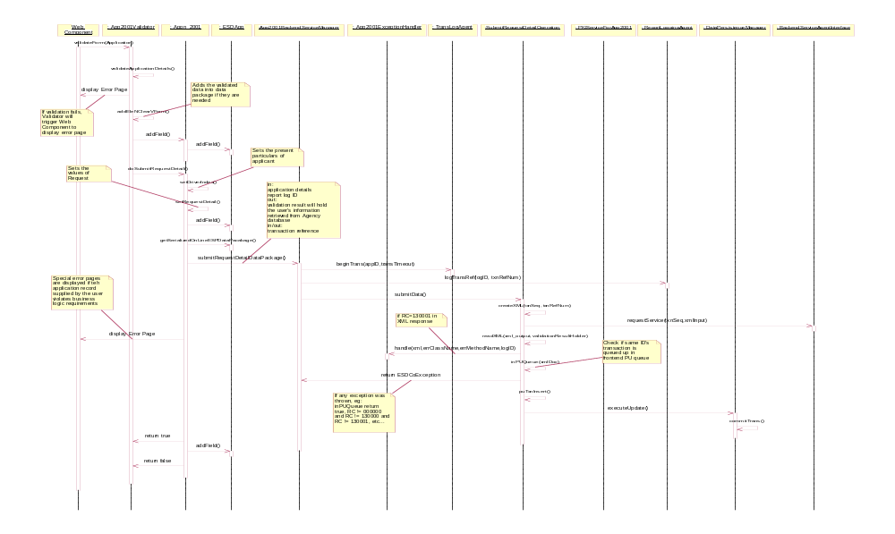
Sequence Diagram 2: Submit Request Data Package Operation

Submit Application Before Payment Operation

Purpose of the function
- insert further application details input by user into a datapackage
- user signs on the input application details
- datapackage uploaded to content server
- insert extra info, counter sign the package and store it up

Activated Scenarios
- APP2001-7

Input to the function
Variable Name | Type | Description
applicationRecord | byte[] | serialized datapackage
txnRefNum | String | transaction reference number

Output or Result of the function
Variable Name | Type | Description
txnDateStamp | String | transaction date stamp

WEB-Page Processing
No web-page processing is involved.

Object Interaction Diagram
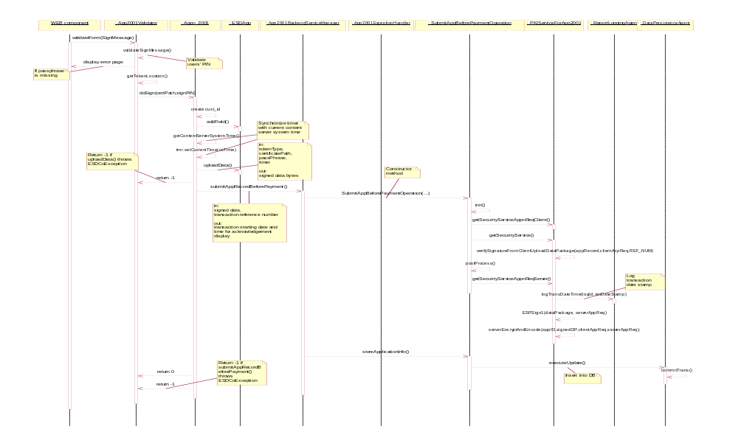
Sequence Diagram 3: Submit App Before Payment Operation

Submit Payment Operation

Purpose of the function
- retrieve pre-payment application details and payment information according to the transaction reference number
- counter sign the final datapackage
- create pending transaction record ready for periodic update

Activated Scenarios
- APP2001-9

Input to the function
Variable Name | Type | Description
txnRefNum | String | transaction reference number

Output or Result of the function
No specific output for this function. No special result is expected as post-successful-payment transactions are “must-go” transactions and thus even when there are exceptions, they will all be handled internally, thus the same acknowledgement page will be shown at all times.

WEB-Page Processing
No web-page processing is involved.

Object Interaction Diagram
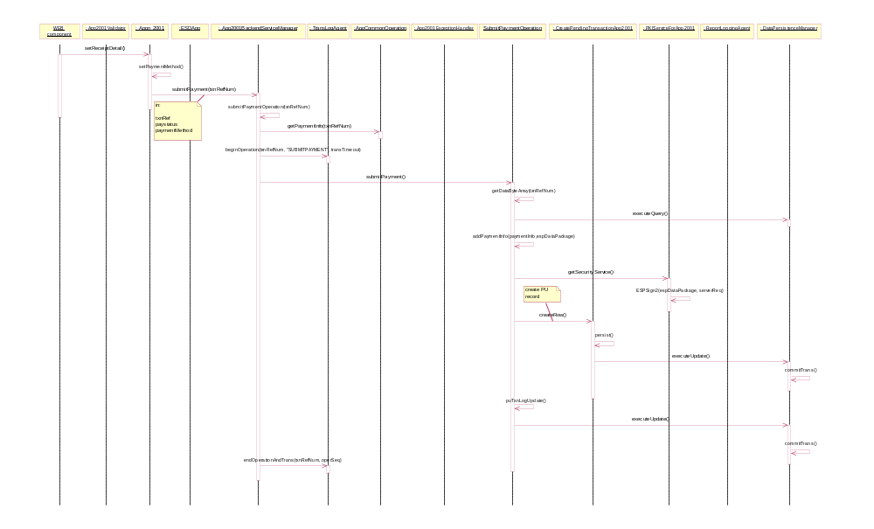
Sequence Diagram 4: Submit Payment Operation

Application Classes Definition Skeleton

Class Name | App2001BackendServiceManager
Description | This is the actual implementation of the Content Server for application APP2001. It’s a sub-class of CORBA skeleton _App2001BackendServiceInterfaceImplBase
Operation | Return Type | Argument | Description
submitRequestDetailDataPackage |  |  | Perform online renewal request.
 | Nil
 |  | applicationRecord : byte[] | Serialized ESPDatapackage containing online request details
 |  | logID : int | ID number for logging purpose
 |  | txnRefNum : StringHolder | Unique transaction reference number
 |  | validationResultHolder : ValidationResultHolder | Validation results returned from backend.
submitAppRecordBeforePayment |  |  | Stores encoded and encrypted application data in front end database before payement
 | String |  | Returns transaction date stamp to applet
 |  | applicationRecord : byte[] | Serialized ESPDatapackage containing transaction details
 |  | txnRefNum : String | Unique transaction reference number
submitPayment |  |  | Prepare PU transactions with uploaded data and payment information
 | Nil
 |  | txnRefNum : String | Unique transaction reference number

Class Name | App2001ExceptionHandler
Description | This class handles all XML responses-related exception with RC=130000 for APP2001
Operation | Return Type | Argument | Description
handle |  |  | The implentation of the exception handling logic
 | Nil
 |  | xml : byte[] | The XML message in byte array format
 |  | errclassname: String | The exception-throwing class’ name
 |  | errmethodname: String | The exception-throwing method’s name
 |  | logID : int | The ID for transaction-logging purpose

Class Name | SubmitRequestDetailOperation
Description | This class is for conducting online renewal request
Attribute | Type | Description
containEncryptedField | boolean | True if online request contains encrypted fields, false otherwise
applicationRecord | byte[] | Uploaded data for online request
logID | int | ID for logging purpose
documentDriver | String | Package name of XML parser
dtdNamePath | String | Name of DTD used in creating and reading XML messages
txnRefNum | StringHolder | Unique transaction reference number
tranID | String | Online transaction ID
veh_id | String | Vehicle ID returned from backend
espDataPackage | ESPDataPackage | Class containing transaction specific data
deArray | DataElement[] | Array of DataElement for data extraction from datapackage
validationResultHolder | ValidationResultHolder | CORBA object for holding validation result returned from backend
Operation | Return Type | Argument | Description
submitData |  |  | Perform online renewal request
 | Nil
 |  | Nil
createXML |  |  | Create XML request message
 | byte[] |  | XML request in byte array format
 |  | txnSeq : int | Transaction sequence number
 |  | RefNum : String | Unique transaction reference number
readXML |  |  | Parse XML response message from backend
 | int |  | return value
 |  | xmlInput : byte[] | XML response from backend
 |  | validationResult : ValidationResult | Validation result to be passed back to applet
inPUQueue |  |  | To check whether and PU transaction of the same vehicle ID was queued up in frontend
 | boolean |  | True if transaction is in queue, false otherwise
 |  | document : Document | XML response from backend
puTxnLogInsert |  |  | Insert transaction record into frontend DB
 | boolean |  | True if insertion is successful, false otherwise
 |  | Nil

Class Name | SubmitAppBeforePaymentOperation
Description | This class verifies client upload, sign it, and store it up before user conducts payment.
Attribute | Type | Description
logID | int | ID for logging purpose
applicationRecord | byte[] | Uploaded pre-payment data
verifiedDataPackage | ESPDataPackage | Verified dataPackage
signedDataPackage | ESPDataPackage | Signed dataPackage (ESP Sign1)
csDataPackage | ESPDataPackage | Server encrypted and coded dataPackage
txnDateStamp | String | Transaction date stamp
txnRefNum | String | Unique transaction reference number
Operation | Return Type | Argument | Description
SubmitAppBeforePaymentOperation |  |  | Constructor operation
 | Nil
 |  | securityService : SecurityServicesInterface | SecurityServiceInterface from PKIService
 |  | applicationRecord : byte[] | Application detail uploaded by user
 |  | pkiService : PKIServiceForApp2001 | An instance of PKIService specifically for APP2001, providing all PKI related services
 |  | txn_ref_num : String | Unique transaction reference number
storeApplicationInfo |  |  | Store application info in front end DB
 | String |  | Transaction date time stamp
 |  | Nil
postProcess |  |  | Generate and log transaction time stamp
 | Nil
 |  | Nil
init |  |  | Initiation of the worker class SubmitAppBeforePaymentOperation
 | Nil
 |  | Nil

Class Name | SubmitPaymentOperation
Description | This class takes care of all post-payment operations including a periodic update action.
Attribute | Attribute | Description
txnRefNum | String | Unique transaction reference number
periodicUpdateID | String | Periodic update ID
paymentInfo | PaymentInfo | Payment information from payment gateway
espDataPackage | ESPDataPackage | Class containing transaction specific data
Operation | ReturnType | Argument | Description
getDataByteArray |  |  | Retrieve data stored in front end DB before conducting payment
 | byte[] |  | Application record in byte array format
 |  | txnRefNum : String | Unique transaction reference number
addPaymentInfo |  |  | Insert current payment information data in to the transaction’s ESPDataPackage
 | Nil
 |  | paymentInfo : PaymentInfo | Payment information from payment gateway
 |  | dataPackage : ESPDataPackage | The dataPackage to add payment info into
puTxnLogUpdate |  |  | Update front end record of current transaction when PU is successful
 | boolean |  | True if succeeded, false otherwise
 |  | Nil
submitPayment |  |  | Conducts all post-payment confirm operations
 | Nil
 |  | Nil

Class Name | CreatePendingTransactionApp2001
Description | This class prepares records for periodic update transactions. It’s a sub-class of CreatePendingTransaction in package AppCommon.
Operation | Return Type | Argument | Description
createPendingTransactionData |  |  | Creates relevant data for periodic update operation
 | Nil
 |  | Nil

Class Name | PKIServiceForApp2001
Description | This class, as a singleton, provides APP2001 with PKI related operation and variables. It’s a sub-class of PKISerivce under package AppCommon.
Operation | Return Type | Argument | Description
getSecurityServiceAppnReqClient |  |  | Returns sequence for client-side encryption
 | ApplicationRequirement |  | Sequence for client-side encryption
 |  | identifier : String | Identifier for ApplicationRequirement
getSecurityServiceAppnReqServer |  |  | Returns sequence for server-side encryption
 | ApplicationRequirement |  | Sequence for server-side encryption
 |  | identifier : String | Identifier for ApplicationRequirement

Class Name | ESDClientApplet
Description | This class delegates client side actions specific to Application 2001 to different classes
Attribute | Type | Description
appn2001 | Appn_2001 | Application 2001 class instance
esdClientApplet | com.esd.pki.ClientApplet.ESDApp | Client side PKI module
orb | org.omg.CORBA.ORB | ORB instance for communication with CORBA service
validator | App2001Validator | Application 2001 validator class instance
wsSettings | com.esd.commonclasses.WebServerSettings | Common component for storage of environment settings

Class Name | App2001Validator
Description | This class performs user input validation specific to Application 2003
Attribute | Type | Description
appn | Appn_2001 | A reference to Appn_2001 instance
args | Object [] | List of parameters to be set for the javascript displayErrPage method
vForm | Hashtable | Hashtable for storing the user data captured
flushFlag | Boolean | Flag for indicating whether data have already been added to the datapackage
jsFrame | JSObject | A reference to the javascript_container frame
Operation | Return Type | Argument | Description
validateForm |  |  | Validate user input data according to business rules
 | Boolean |  | True indicates that validation succeeds, otherwise, validation fails
 |  | formID : String | Unique key identifying form name within the application
validateSignMessage |  |  | Validate the sign message page
 | Boolean |  | True indicates that validation succeeds, otherwise, validation fails
 |  | Nil

Class Name | Appn_2001
Description | This class contains attributes and performs actions specific to Application 2001
Attribute | Type | Description
COURT_ORDER_LIST_NUM | int | Holds the number of outstanding court order
PREVIOUS_CHANGE_ADDRESS_OPTION | int | Holds the previous changing address option
addChangedOption | int | Stores the changing address option
app2001BackendServiceInterface | App2001BackendServiceInterface | A reference to the 2001 backend service manager
pstatus | String | Holds the payment status
currentAddress | CurrentAddress | Holds the currently residential and postal addresses of applicant
courtOrderList | CourtOrderDetails[] | Holds the outstanding court order details
validationResult | ValidationResult | Holds the result from backend after the submit request details online call
ENG_NAME | String | Stores English name of applicant
ID_TYPE | String | Stores ID Type of applicant
ID_NUM | String | Stores ID number of applicant
TEL_NUM | String | Stores contact number of applicant
CORR_LEN_IND | String | Stores the wearing corrective lenses indicator
HEAR_AID_IND | String | Stores the wearing hearing aids indicator
PHY_HAND_IND | String | Stores the physical handicap indicator
ID_DOC_IMG | String | Stores the supporting ID document path
EXEMPT_LETTER_IMG | String | Stores the supporting exemption document path
HKID | String | Stores the supporting approval document path
TOKEN_LOC | String | Stores the certificate location
fieldCodeTable | Hashtable | Stores all application field codes for insertion of data into datapackage
APP_DATE_TIME | String | Content server system time at client data upload
Operation | Return Type | Argument | Description
abortApplication |  |  | Reset all references and perform garbage collection
 | Nil
 |  | Nil
addAttachement |  |  | Call add attachment method of the PKI client instance to add file to the data package
 | Nil
 |  | fieldCode:String | Field code sought from field code table
 |  | path:String | File path
doSubmitRequest |  |  | Make an online call to the backend to submit request details
 | boolean |  | Returns true if the request details can be made, false if otherwise
 |  | Nil
addField |  |  | Call add field method of the PKI client instance to add data to the data package
 | Nil
 |  | fieldCode : String | Field code sought from field code table
 |  | fieldValue : String | Data value
 |  | charType : String | Character type
 |  | encoding : String | Language type
setReceiptDetail |  |  | Store receipt details and trigger submit payment method
 | Nil
 |  | Nil
doSign |  |  | Sign and submit the client data package
 | int |  | Returns >0 if successful, <0 if otherwise
 |  | Nil

Constraints to The Application

The front end system is responsible for rejecting any transactions with legal ID equals to that of any of the transactions queued up in the pending transaction message queue to avoid transactions with same legal IDs being passed to backend during periodic update transactions. This function was fully implemented with one exception: if a transaction conducts a Submit Request Data Package Operation (the point where the initial online request is done) before another earlier transaction with the same legal ID completes a Submit Payment Operation (the point where pending transaction records are generated), frontend system would not be able to reject it.

Appendices

The structs DriverIndex and RequestDetail in the IDL file app2001.idl are now logically obsolete and could be removed provided that both the content tier source codes and applet tier source codes are rid of them (eg. include statements, etc,).

